This is Mary Schafer
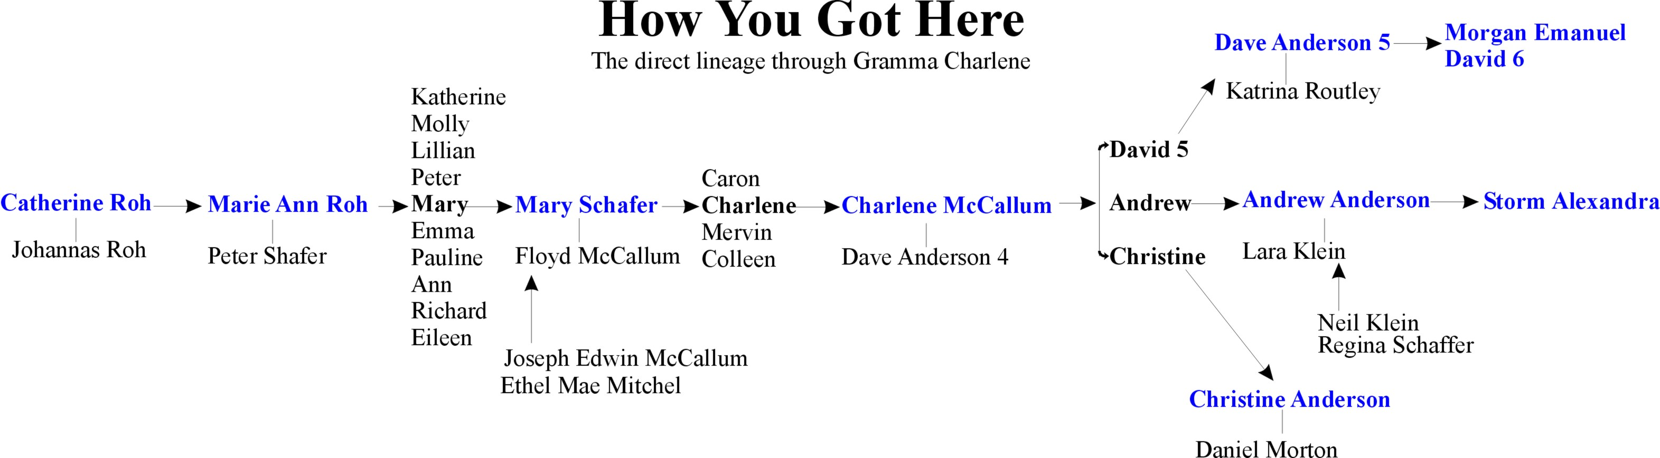
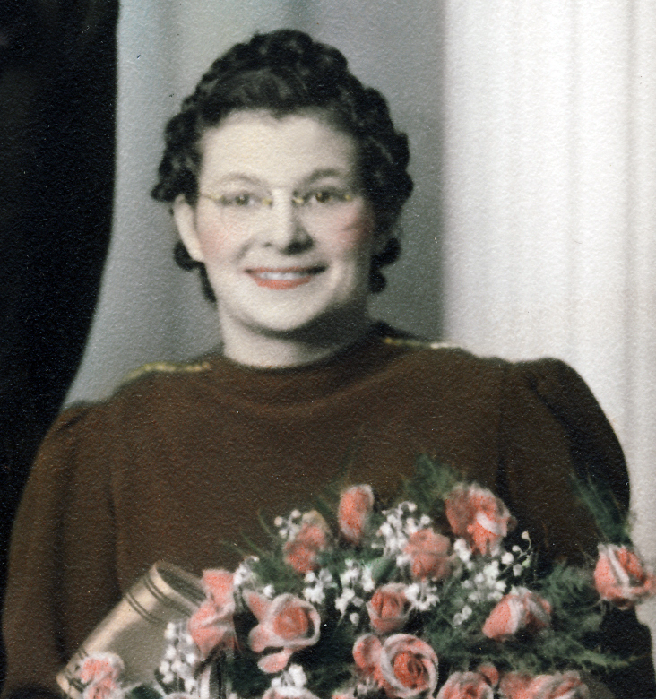
She is Gramma Charlene’s mother.
She was born June 5, 1916.
The 5th surviving child of Marie Ann Roh & Peter Shafer.
She married Floyd Clayton McCallum on Christmas eve 1940 in Medicine Hat, Alberta.

They had 4 children:
Caron,
Charlene,
Mervin and Colleen.

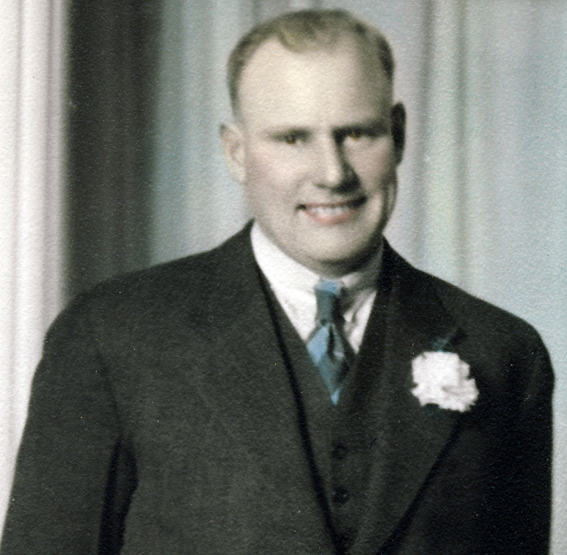
This is Floyd Clayton McCallum:
Gramma Charlene’s father.
He was one of twins born to Joseph Edwin McCallum & Ethel Mae Mitchel in a tent on October 27, 1910 at Carmangey, Alberta.

Floyd’s twin Glenn died in 1940.

Floyd farmed at Queenston & Strathmore, Alberta.

